***ASSIGNMENT***

***Module 3 (Testing on Live Application)***

1. **What is RDBMS ?**

**A->** The software used to store, manage, query, and retrieve data stored in a relational database is called a relational database management system (RDBMS) The RDBMS is the most popular database system among organizations across the world However, since SQL was invented after the initial development of the relational model, it is not necessary for RDBMS use.

1. **What is SQL ?**

**A->**  SQL is a programming language for storing and processing information in a relational database A relational database stores information in tabular form, with rows and columns representing different data attributes and the various relationships between the data values When data needs to be retrieved from a database, SQL is used to make the request.

Structured Query Language (SQL) is a standardized programming language that is used to manage [relational databases](https://www.techtarget.com/searchdatamanagement/definition/relational-database) and perform various operations on the data in them.

1. **Write SQL Commands ?**

* **A->** There are five types of SQL commands: DDL, DML, DCL, TCL, and DQL.SQL commands are instructions. It is used to communicate with the database. It is also used to perform specific tasks, functions, and queries of data. SQL can perform various tasks like create a table, add data to tables, drop the table, modify the table, set permission for users.

*\*DDL SQL Commands\**

**Create :-**  It is used to create a new table in the database.

**Drop :-** It is used to delete both the structure and record stored in the table.

**Alter :**- It is used to alter the structure of the database. This change could be either to modify the characteristics of an existing attribute or probably to add a new attribute.

**Truncate :**- It is used to delete all the rows from the table and free the space containing the table.

*\*DML SQL Commands\**

**Insert :-** The INSERT statement is a SQL query. It is used to insert data into the row of a table.

**Update :-** This command is used to update or modify the value of a column in the table.

**Delete :-** It is used to remove one or more row from a table.

*\*DCL SQL Commands\**

**Grant :-** It is used to give user access privileges to a database.

**Revoke :**- It is used to give user access privileges to a database.

*\*TCL SQL Commands\**

**Commit :-** Commit command is used to save all the transactions to the database.

**Rollback :**- Rollback command is used to undo transactions that have not already been saved to the database.

**Savepoint :-** It is used to roll the transaction back to a certain point without rolling back the entire transaction.

*\*DQL SQL Commands\**

**Select :-** This is the same as the projection operation of relational algebra. It is used to select the attribute based on the condition described by WHERE clause.

1. **What is join ?**

**A-> Structured Query Language (SQL)** allows us to perform some sort of action on a single table in a relational database. These actions can update, create, delete or select a record in that table. What if we had two tables that had different information about the same person, and we wanted to use all of that information to display on that person’s invoice? We would need to use a **join clause** for that.

In this tutorial, we will define what a join clause is, talk about the types of join clauses, and give join examples for each. SQL join statements allow us to access information from two or more tables at once. They also keep our database normalized. Normalization allows us to keep data redundancy low so that we can decrease the amount of data anomalies in our application when we delete or update a record.

1. **Write type of joins**.?

A-> *There are four main types of JOINs in SQL*

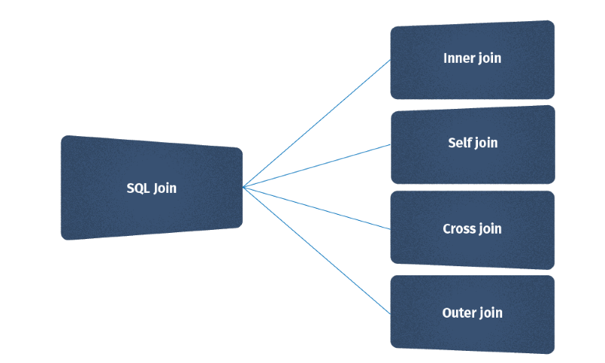

1. **Inner join :-**

Syntax the most frequently used and important of the joins is the INNER JOIN. They are also referred to as an EQUIJOIN. The INNER JOIN creates a new result table by combining column values of two tables (table1 and table2) based upon the join-predicate. The query compares each row of table1 with each row of table2 to find all pairs of rows which satisfy the join-predicate. When the join-predicate is satisfied, column values for each matched pair of rows of A and B are combined into a result row.

SYNTAX: The basic syntax of INNER JOIN is as follows:

SELECT table

1. Column1, table2.column2...FROM table1INNER JOIN table2ON table1.common_filed = table2.common_field;

1. **Self join :-**

The SELF JOIN in SQL, as its name implies, is used to join a table to itself. This means that each row in a table is joined to itself and every other row in that table. However, referencing the same table more than once within a single query will result in an error. To avoid this, SQL SELF JOIN aliases are used.

Syntax

Following is the basic syntax of Self Join in SQL −

SELECT column_name(s)

FROM table1 a, table1 b

WHERE a.common_field = b.common_field;

1. **Cross join :-**

A cross join is a type of join that returns the Cartesian product of rows from the tables in the join. In other words, it combines each row from the first table with each row from the second table. This article demonstrates, with a practical example, how to do a cross join in Power Query.

## Syntax

The syntax of the CROSS JOIN in SQL will look like the below syntax:

SELECT ColumnName_1,

       ColumnName_2,

       ColumnName_N

FROM [Table_1]

     CROSS JOIN [Table_2]

1. **Outer join :-**

Outer joins are joins that return matched values and unmatched values from either or both tables. There are a few types of outer joins: LEFT JOIN returns only unmatched rows from the left table, as well as matched rows in both tables.

SQL statement selects all customers, and all orders:

SELECT Customers.CustomerName, Orders.OrderID  
FROM Customers  
FULL OUTER JOIN Orders ON Customers.CustomerID=Orders.CustomerID  
ORDER BY Customers.CustomerName;